Engineering UI Configuration

**Version 3.3.1**

|  |
| --- |
| **PSL** |
| **3/14/2012** |

Contents

Configuration files related to Engineering UI 3

Adding group of parameter in status parameter sections in Engineering UI 5

Adding group of parameter in monitoring parameter section in Engineering UI 6

Adding raw parameter in Engineering UI 7

Adding commands to Basic Command section of Engineering UI 8

Adding commands to Detailed Commands section of Engineering UI 9

Configure Engineering UI in CMS 10

Configure in applicationcontext.xml 10

Configure in database 10

Configure engineering permissions in CMS 11

## Configuration files related to Engineering UI

The below mentioned configuration files are present in the lib directory.

1. **ncra-subsystemconfig.xml** :

It contains subsystem related information along with subsystemname_engineering.XML file used to generate UI from it.

**Syntax:** Servo subsystem: Under subsystem tag user can mention configuration about subsystem. Tag <engXML> specifies name of xml file used to generate enginerring UI.

<subsystems>

<subsystem>

<name>servo</name>

<connectionurl>127.0.0.1:7775</connectionurl>

<commandfile>servo_commands.xml</commandfile>

<version>1</version>

<engXML>servo_engineering.xml</engXML>

</subsystem>

<subsystem>

<name>sentinal</name>

<connectionurl>127.0.0.1:7775</connectionurl>

<commandfile>sentinal_commands.xml</commandfile>

<version>1</version>

<engXML>sentinal_engineering.xml</engXML>

</subsystem>

</subsystems>

1. **subsystemname_commands.XML** (e.g. servo_commands.xml) :

It contains all the supported commands and supported responses with validation. It also contains Monitoring parameter with validation. Refer to servo_commands.xml for a sample subsystem command, response and monitoring parameter configuration.

The command issued from UI is validated against command mentioned in this xml. And the responses received from monitoring simulator are validating against responses mentioned in this xml.

1. **subsystemname_engineering.XML** (e.g. servo_engineering.xml) :

It contains four section **Status param**, **Monitoring param**, **Basic commands** and **Detailed commands** for particular sub system. Engineering UI is loaded from this xml during CMS initialization. This XML defines contents of the Engineering UI.

User can add a status parameter or Monitoring parameter to UI through this engineering xml. The newly added parameter should be pre-configured as monitoring parameter in **subsystemname_commands.XML**

User can add a command to Basic Commands or Detailed commands section of **subsystemname_engineering.XML**. The command added should have been pre-configured in the subsystemname_commands.XML.

If command is not specified in subsystemname_commands.xml then UI shows “Command not found” error message.

## Adding group of parameter in status parameter sections in Engineering UI

To add group of parameter in status or monitoring section in engineering UI, User should add tag of **<paramsgroup>** under status or monitoring section of subsystem_engineering.xml. If the parameter is added to both the sections it will be visible in both sections.

For e.g. if user wants to add XYZ group with parameter in status params section the xml syntax is:

<statusparams>

<paramsgroup>

<groupname>XYZ</groupname>

<param>

<label>param1 </label>

<paramname>timeofday</paramname>

<type>datetime</type>

<paramvalue>10:12:20</paramvalue>

</param>

<param>

<label>param2</label>

<paramname>az_cp</paramname>

<type>angle</type>

<paramvalue>123:50:10</paramvalue>

</param>

</paramsgroup>

</statusparams>

The fields specified above indicate the following:

<label> - label to be displayed on screen

<paramname> - the actual name of the parameter as received in monitoring response

<type> - the data type of the parameter. To display the parameter as bit where the background color changes as per bit value the <type> should have value as **bit**

<paramvalue> - the default parameter value to be displayed on UI. If no default value is present this field can be left blank.

The added section and parameters will be visible in UI as displayed below:

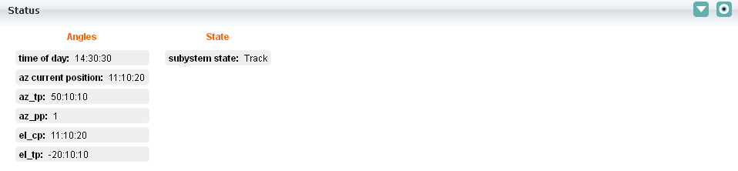

## Adding group of parameter in monitoring parameter section in Engineering UI

To add group of parameter in monitoring section in engineering UI, User should add tag of **<detailedparams>** under monitoring section of subsystem_engineering.xml.

For e.g. if user wants to add XYZ group with parameter in Monitoring params section the xml syntax is:

<detailedparams>

<paramsgroup>

<groupname>ABC </groupname>

<param>

<label>time of day</label>

<paramname>timeofday</paramname>

<type>datetime</type>

<paramvalue>10:12:20</paramvalue>

</param>

</paramsgroup>

</detailedparams>

The fields specified above indicate the following:

<label> - label to be displayed on screen

<paramname> - the actual name of the parameter as received in monitoring response

<type> - the data type of the parameter. To display the parameter as byte the <type> should have value as **bit**

<paramvalue> - the default parameter value to be displayed on UI. If no default value is present this field can be left blank.

The added section and parameters will be visible in UI as displayed below:

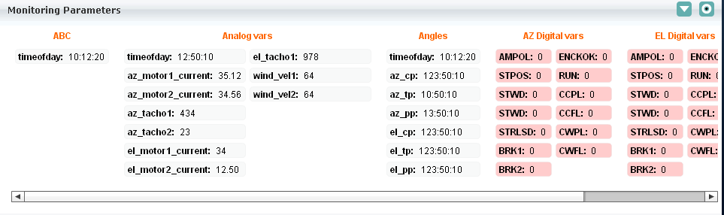

All status and monitoring parameter values are updated when CMS receive response from wrapper.

## Adding raw parameter in Engineering UI

To add a raw parameter to engineering engineering UI, User should add tag of <paramsgroup> under <rawparams> section of subsystem_engineering.xml.

This raw param value is sent through monitoring parameter with name **rawstream**. The following is the syntax for adding a raw parameter to Engineering UI:

<rawparams>

<paramsgroup>

<groupname>Raw Stream</groupname>

<param>

<label>raw stream</label>

<paramname>rawstream</paramname>

<type>string</type>

<paramvalue> 111111111111111000000000000000000000000000000000000001111111111100000000000

</paramvalue>

<bgcolor>0x0000FF</bgcolor>

</param>

</paramsgroup>

</rawparams>

The fields specified above indicate the following:

<label> - label to be displayed on screen

<paramname> - the actual name of the parameter as received in monitoring response

<type> - the data type of the parameter. To display the parameter as byte the <type> should have value as **bit**

<paramvalue> - the default parameter value to be displayed on UI. If no default value is present this field can be left blank.

The raw parameter section will be visible in UI as displayed below:

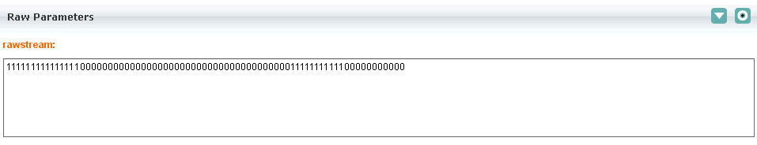

## Adding commands to Basic Command section of Engineering UI

To add a command in basic command section user must add **<command>** tag under basic command tag of subsystemname_engineering.xml. The command syntax and validation should have been configured under supported commands tag of subsystemname_commands.xml file.

To add command System shutdown in basic section the xml syntax is:

<basiccommands>

<command>

<name>System shutdown</name>

<id>1</id>

<syntax></syntax>

<sample></sample>

</command>

</basiccommands>

The added command will be visible in UI as displayed below:

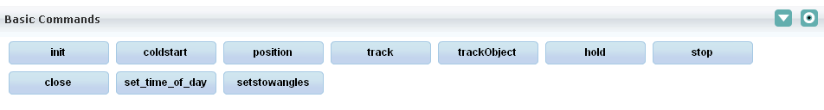

If command is not configured in subsystemname_commands.xml and then on executing the command then the user will get an error message “command not found”.

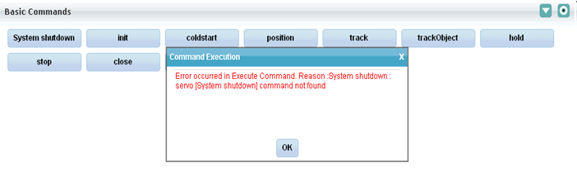

## Adding commands to Detailed Commands section of Engineering UI

To add a command in detailed command section user must add **<command>** tag under detailed command tag of subsystemname_engineering.xml.

The command syntax and validation should have been configured under supported commands tag of subsystemname_commands.xml file.

The look and feel of the added command will be similar to the basic command.

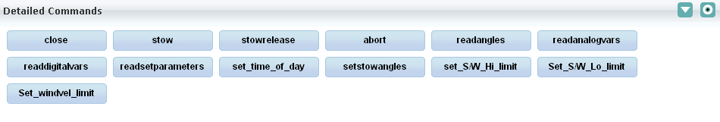

## Configure Engineering UI in CMS

### Configure in applicationcontext.xml

User must enter entry of URL in applicationcontext.xml (file path : tomcat/webapps/cms-web/web-inf/applicationcontext.xml) under <security:http> tag.

Entry should be in following format.

e.g.

<security:intercept-url

pattern=*"/engineeringUIController\.htm\?systemID=servo"* access=*"BF_VIEW_ENGINEERING****_servo****"* />

In above example user added entry for servo subsystem.

Similar entry can added for sentinal subsystem but user must change system id to sentinal which is same name as of subsystem name mentioned in ncra-subsystemconfig.xml.

### Configure in database

Add above mentioned permission in database

e.g.

***BF_VIEW_ENGINEERING_servo*** in database using the query specified below.

Database Query to add permission:

**INSERT INTO ncracmsdb.t_group_permission values (NULL,'BF_VIEW_ENGINEERING_xxx','xxx ENGINEERING','YES');**

**xxx**:- it is the subsystem name for which Engineering UI is required

If all above configurations are done then restart tomcat.

### Configure engineering permissions in CMS

#### Assign the newly added permission to appropriate role

1. Login as admin
2. Select Role Management under Admin tab as shown below:

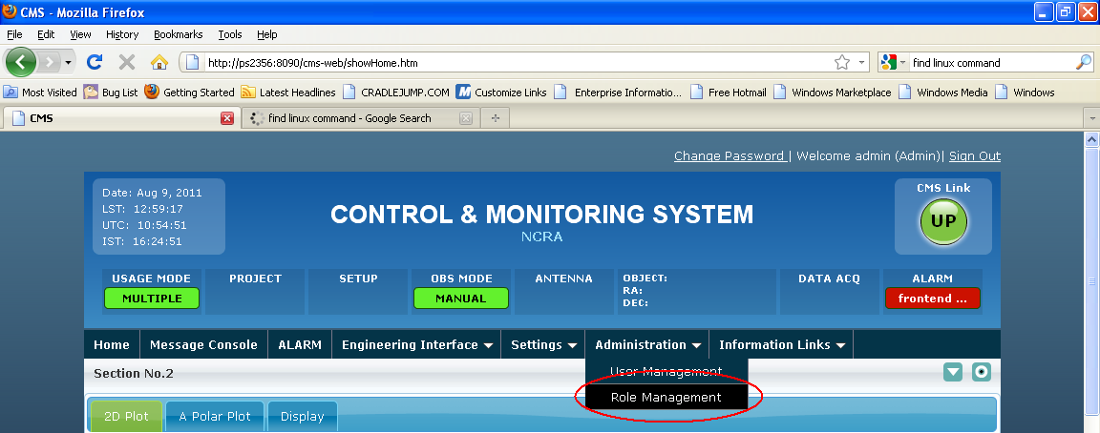

1. Select the role for which the permission needs to be assigned. For e.g. the below screen shot display the edit role operation for Expert Role.

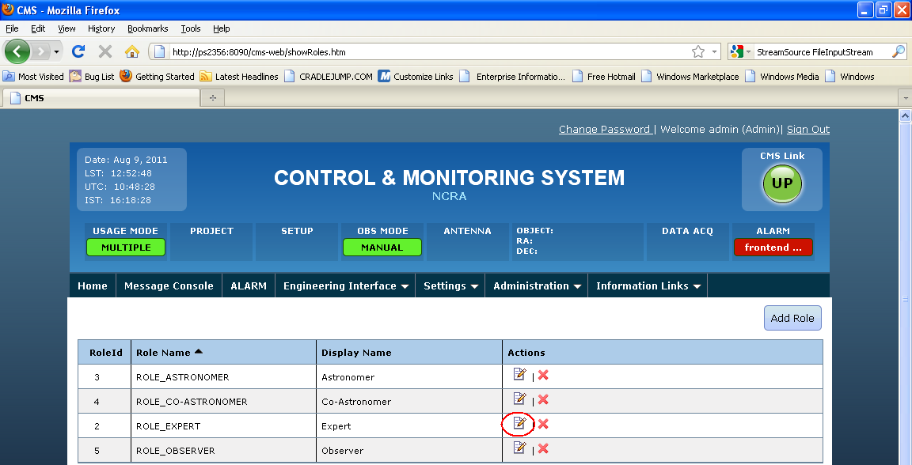

1. Select the added Permission along with other required permission as shown below and click on update to apply the permissions to the Role.

